
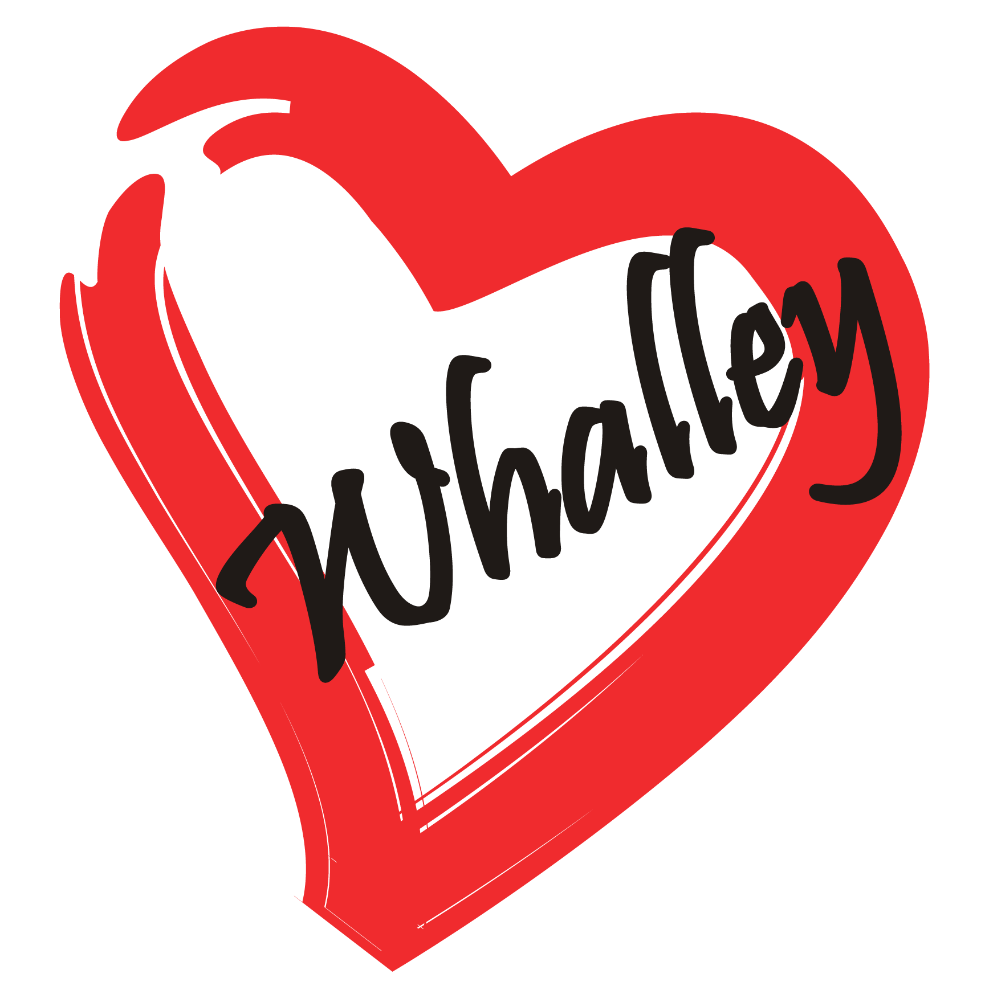

WHALLEY COMMUNITY IMPROVEMENT ASSOCIATION

PUB NIGHT
FRIDAY
JUNE 21, 2019
5:00 PM
WHALLEY LEGION
10767 KING GEORGE BLVD

TICKETS - $ 25.00 CALL 604 961 – 2170 FOR TICKETS
INCLUDES SUPPER
Bring your dancing shoes!

